**Pluralsight UI Readme**

Installation steps:

1. The project contains a basic html page with some JQuery to call the backend RESTful web service. (which is part of the pluralsightquiz repository)
2. You can download any version of Apache Tomcat (I tested with 8.5) and simply add the pluralsightclient project to the server. Make sure to change the default port number settings in server.xml of tomcat (I tested with 8081) since the web service will be running on 8080.

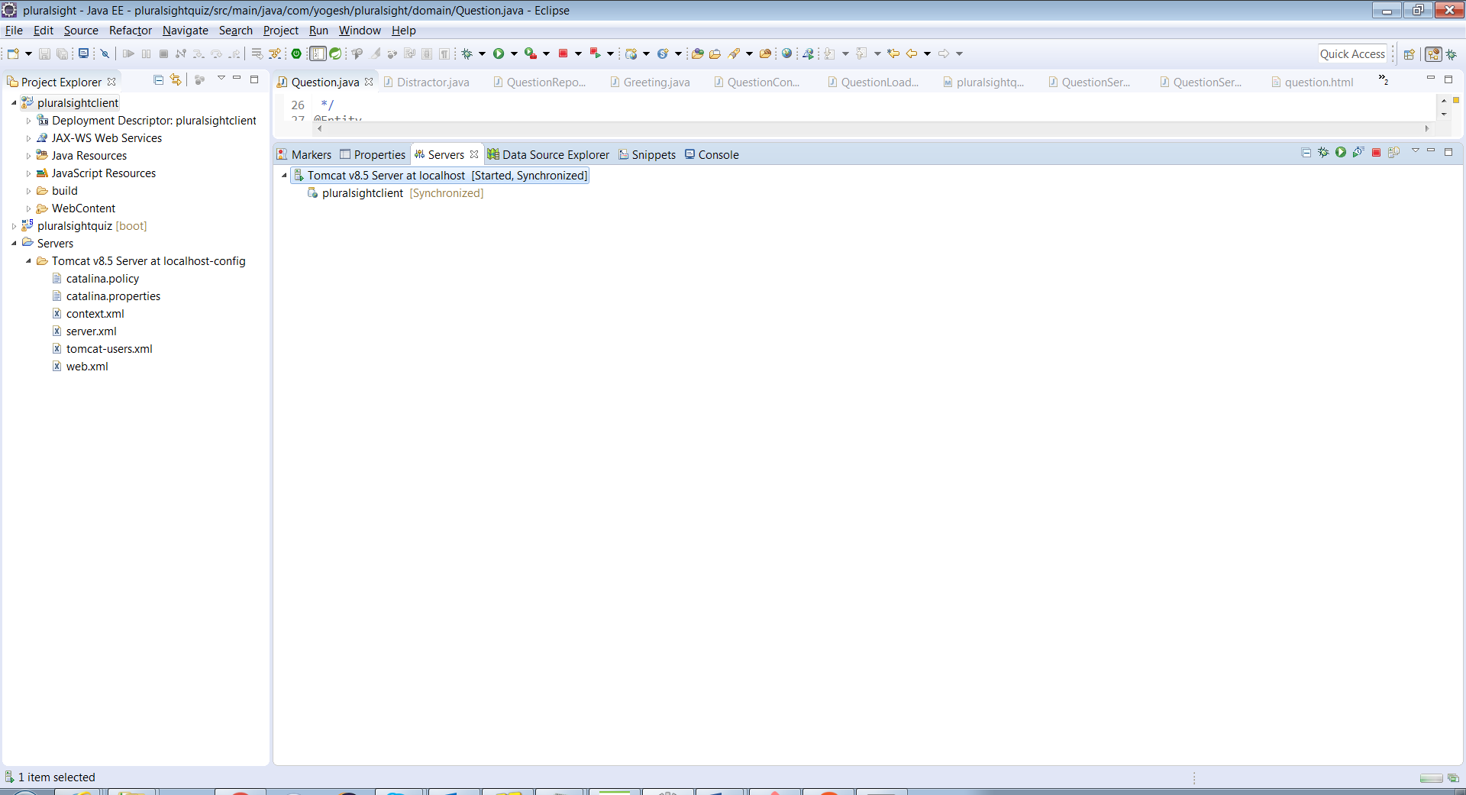

1. After, starting Tomcat, you can get to the page by going to the below URL:

<http://localhost:8081/pluralsightclient/question.html>